#include <iostream>

using namespace std;

class Tstudent{

public:

static float m_classmoney ;

void initstudent(char name[])

{

cin >> name;

}

void expendmoney(float money)

{

m_classmoney = m_classmoney - money;

}

void showmoney()

{

cout << "班费还剩余" << m_classmoney <<endl;

}

private:

float money;

};

float Tstudent::m_classmoney = 1000;

int main()

{

Tstudent A, B, C;

A.expendmoney(50);

A.showmoney();

B.expendmoney(98.5);

B.showmoney();

C.expendmoney(500.53);

C.showmoney();

}

代码

结果

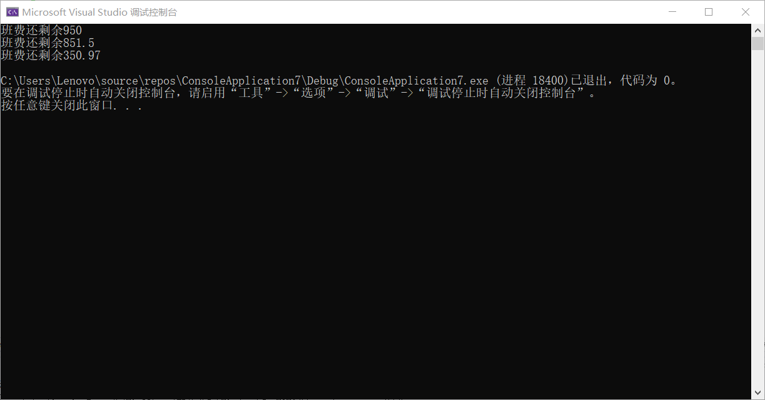

感悟：学会在c++程序上使用值传递和静态函数，加深对静态函数和值传递的理解和使用。而且实验中也让我学会了在成员中的参数如何使用字符类型

Copyright ©2021-2099 luanxiang wang.All rights reserved